Datacamp Statics 1

Graphical Exploratory data analysis
- The process of organizing, plotting, and summarizing a data set.
“Exploratory data analysis can never be the whole story, but nothing else can serve as the foundation stone. “ – John Tukey
from sklearn import datasets
import pandas as pd
import numpy as np
import matplotlib.pyplot as plt
plt.style.use('ggplot')

import pandas as pd
df_swing = pd.read_csv('D:\\Dev\\DataCamp\\2DeepLearningInPython\\3SupervisedLearningWithScikit-Learn\\StatisticalThinkingPart1\\2008_swing_states.csv')
df_swing[['state','county','dem_share']]
print(df_swing.head())
state county total_votes dem_votes rep_votes dem_share
0 PA Erie County 127691 75775 50351 60.08
1 PA Bradford County 25787 10306 15057 40.64
2 PA Tioga County 17984 6390 11326 36.07
3 PA McKean County 15947 6465 9224 41.21
4 PA Potter County 7507 2300 5109 31.04
_ = plt.hist(df_swing['dem_share'])
_ = plt.xlabel('percent of votes for Obama')
_ = plt.ylabel('number of counties')
plt.show()
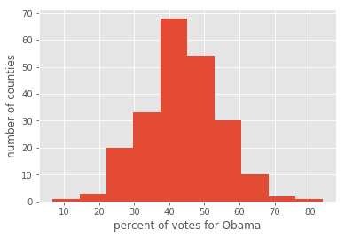
bin_edges = [0,10,20,30,40,50,60,70,80,90,100]
_ = plt.hist(df_swing['dem_share'], bins=bin_edges)
plt.show()
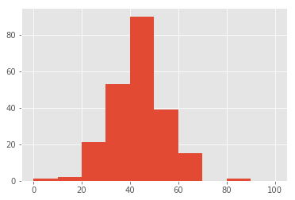
_ = plt.hist(df_swing['dem_share'], bins=20)
plt.show()
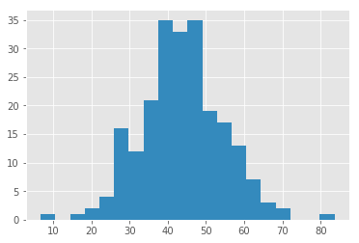

Seaborn
- An excellant Matplotlib-based statistical data visualization package written by Michael Waskom
import seaborn as sns
sns.set()
_ = plt.hist(df_swing['dem_share'])
_ = plt.xlabel('percent of votes for Obama')
_ = plt.ylabel('number of counties')
plt.show()
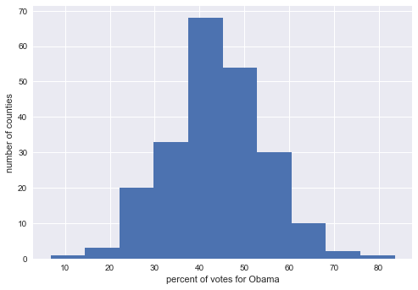

Plotting a histogram of iris data
For the exercises in this section, you will use a classic data set collected by botanist Edward Anderson and made famous by Ronald Fisher, one of the most prolific statisticians in history. Anderson carefully measured the anatomical properties of samples of three different species of iris, Iris setosa, Iris versicolor, and Iris virginica. The full data set is available as part of scikit-learn. Here, you will work with his measurements of petal length.
Plot a histogram of the petal lengths of his 50 samples of Iris versicolor using matplotlib/seaborn's default settings. Recall that to specify the default seaborn style, you can use sns.set(), where sns is the alias that seaborn is imported as.
The subset of the data set containing the Iris versicolor petal lengths in units of centimeters (cm) is stored in the NumPy array versicolor_petal_length.
In the video, Justin plotted the histograms by using the pandas library and indexing the DataFrame to extract the desired column. Here, however, you only need to use the provided NumPy array. Also, Justin assigned his plotting statements (except for plt.show()) to the dummy variable . This is to prevent unnecessary output from being displayed. It is not required for your solutions to these exercises, however it is good practice to use it. Alternatively, if you are working in an interactive environment such as a Jupyter notebook, you could use a ; after your plotting statements to achieve the same effect. Justin prefers using . Therefore, you will see it used in the solution code.
import matplotlib.pyplot as plt
import seaborn as sns
from sklearn import datasets

sns.set()
iris = datasets.load_iris()
X = iris.data
y = iris.target

df = pd.DataFrame(X, columns=iris.feature_names)
df.head()
 | sepal length (cm) | sepal width (cm) | petal length (cm) | petal width (cm)
0 | 5.1 | 3.5 | 1.4 | 0.2
1 | 4.9 | 3.0 | 1.4 | 0.2
2 | 4.7 | 3.2 | 1.3 | 0.2
3 | 4.6 | 3.1 | 1.5 | 0.2
4 | 5.0 | 3.6 | 1.4 | 0.2
versicolor_petal_length = [4.7, 4.5, 4.9, 4. , 4.6, 4.5, 4.7, 3.3, 4.6, 3.9, 3.5,
4.2, 4. , 4.7, 3.6, 4.4, 4.5, 4.1, 4.5, 3.9, 4.8, 4. ,
4.9, 4.7, 4.3, 4.4, 4.8, 5. , 4.5, 3.5, 3.8, 3.7, 3.9,
5.1, 4.5, 4.5, 4.7, 4.4, 4.1, 4. , 4.4, 4.6, 4. , 3.3,
4.2, 4.2, 4.2, 4.3, 3. , 4.1]
_ = plt.hist(versicolor_petal_length)
plt.show()
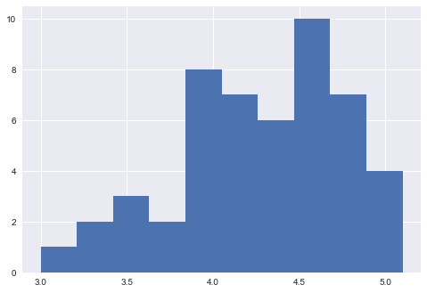

Axis labels!
In the last exercise, you made a nice histogram of petal lengths of Iris versicolor, but you didn't label the axes! That's ok; it's not your fault since we didn't ask you to. Now, add axis labels to the plot using plt.xlabel() and plt.ylabel(). Don't forget to add units and assign both statements to _. The packages matplotlib.pyplot and seaborn are already imported with their standard aliases. This will be the case in what follows, unless specified otherwise.
# Plot histogram of versicolor petal lengths
_ = plt.hist(versicolor_petal_length)

# Label axes
_ = plt.xlabel('petal length (cm)')
_ = plt.ylabel('count')

# Show histogram
plt.show()
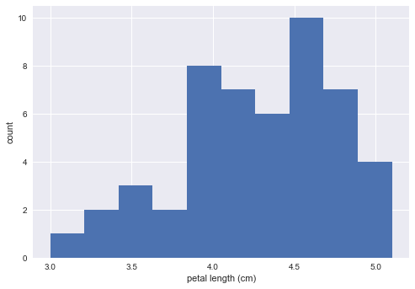

Adjusting the number of bins in a histogram
The histogram you just made had ten bins. This is the default of matplotlib. The "square root rule" is a commonly-used rule of thumb for choosing number of bins: choose the number of bins to be the square root of the number of samples. Plot the histogram of Iris versicolor petal lengths again, this time using the square root rule for the number of bins. You specify the number of bins using the bins keyword argument of plt.hist().
The plotting utilities are already imported and the seaborn defaults already set. The variable you defined in the last exercise, versicolor_petal_length, is already in your namespace.
# Import numpy as np. This gives access to the square root function, np.sqrt().
import numpy as np

# Determine how many data points you have using len()
# Compute number of data points: n_data
n_data = len(versicolor_petal_length)

# Compute the number of bins using the square root rule.
# Number of bins is the square root of number of data points: n_bins
n_bins = np.sqrt(n_data)

# Convert the number of bins to an integer using the built in int() function.
n_bins = int(n_bins)

# Generate the histogram and make sure to use the bins keyword argument.
_ = plt.hist(versicolor_petal_length, bins=n_bins)

# Label axes
_ = plt.xlabel('petal length (cm)')
_ = plt.ylabel('count')

plt.show()
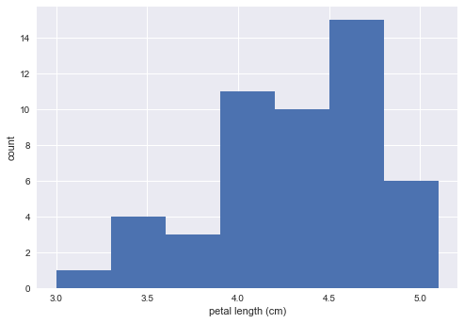

Binning bias
- The same data may be interpreted differently depending on choice of bins
- also the actual value get swept under the bin
To remedy

Bee swarm plot

_ = sns.swarmplot(x='state', y='dem_share', data=df_swing)
_ = plt.xlabel('state')
_ = plt.ylabel('percent of vote for Obama')
plt.show()
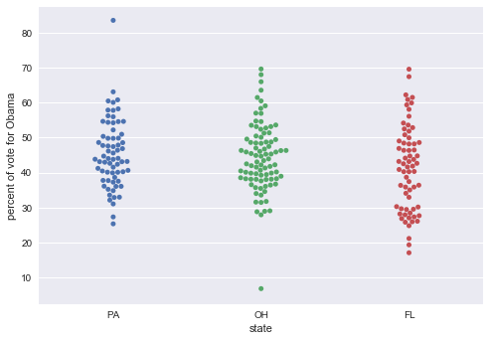
Make a bee swarm plot of the iris petal lengths. Your x-axis should contain each of the three species, and the y-axis the petal lengths. A data frame containing the data is in your namespace as df.
In the IPython Shell, you can use sns.swarmplot? or help(sns.swarmplot) for more details on how to make bee swarm plots using seaborn.
df = pd.read_csv("D:/Dev/DataCamp/2DeepLearningInPython/3SupervisedLearningWithScikit-Learn/StatisticalThinkingPart1/iris_DF.csv")
In the IPython Shell, inspect the DataFrame df using df.head(). This will let you identify which column names you need to pass as the x and y keyword arguments in your call to sns.swarmplot().
df.head()
 | Unnamed: 0 | sepal length (cm) | sepal width (cm) | petal length (cm) | petal width (cm) | species
0 | 0 | 5.1 | 3.5 | 1.4 | 0.2 | setosa
1 | 1 | 4.9 | 3.0 | 1.4 | 0.2 | setosa
2 | 2 | 4.7 | 3.2 | 1.3 | 0.2 | setosa
3 | 3 | 4.6 | 3.1 | 1.5 | 0.2 | setosa
4 | 4 | 5 | 3.6 | 1.4 | 0.2 | setosa
Use sns.swarmplot() to make a bee swarm plot from the DataFrame containing the Fisher iris data set, df. The x-axis should contain each of the three species, and the y-axis should contain the petal lengths.
_ = sns.swarmplot(x='species', y='petal length (cm)', data=df)
# label the axes
_ = plt.xlabel('Species')
_ = plt.ylabel('Petal length')
plt.show()
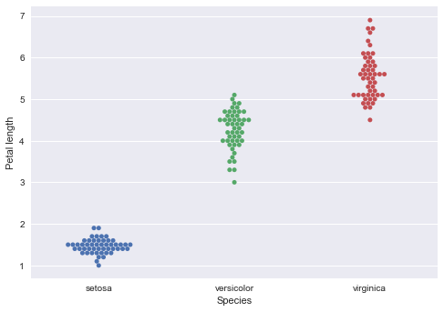

Interpreting a bee swarm plot
Which of the following conclusions could you draw from the bee swarm plot of iris petal lengths you generated in the previous exercise? For your convenience, the bee swarm plot is regenerated and shown to the right.
- All I. versicolor petals are shorter than I. virginica petals.
- I. setosa petals have a broader range of lengths than the other two species.
- I. virginica petals tend to be the longest, and I. setosa petals tend to be the shortest of the three species.
- I. versicolor is a hybrid of I. virginica and I. setosa.
ANSWER: virginica petals tend to be the longest, and I. setosa petals tend to be the shortest of the three species
Correct! Notice that we said "tend to be." Some individual I. virginica flowers may be shorter than individual I. versicolor flowers. It is also possible that an individual I. setosa flower may have longer petals than in individual I. versicolor flower, though this is highly unlikely, and was not observed by Anderson

Empirical cumulative distribution function (ECDF)
x-axis is the sorted data
import numpy as np
x = np.sort(df_swing['dem_share'])
y-axis is evenly spaced data points with maximum of 1 and dividing by total number of data points
y = np.arange(1, len(x)+1) / len(x)
by default, plt uses line to connect data points, to plot ECDF we need points (marker='.' and linstyle is none)
_ = plt.plot(x,y, marker='.', linestyle='none')
_ = plt.xlabel('percent of vote for Obama')
_ = plt.ylabel('ECDF')
We use plt.margin() function to make sure none of the data points run over the side of the plot area and choosing 2% area provides bumper all around the plot.
plt.margins(0.02)
plt.show()

Computing the ECDF
In this exercise, you will write a function that takes as input a 1D array of data and then returns the x and y values of the ECDF. You will use this function over and over again throughout this course and its sequel. ECDFs are among the most important plots in statistical analysis. You can write your own function, foo(x,y) according to the following skeleton:
def foo(a,b):
""" State what function does here"""
# Computation performed here
return x, y
The function foo() above takes two arguments a and b and returns two values x and y. The function header
def foo(a,b): contains the function signature foo(a,b), which consists of the function name, along with its parameters. For more on writing your own functions, see DataCamp's course Python Data Science Toolbox (Part 1) here!
# Define a function with the signature ecdf(data). Within the function definition,

# Compute the number of data points, n, using the len() function.

# The xx-values are the sorted data. Use the np.sort() function to perform the sorting.

# The yy data of the ECDF go from 1/n to 1 in equally spaced increments. You can construct this using np.arange().
# Remember, however, that the end value in np.arange() is not inclusive. Therefore, np.arange() will need to go from 1 to n+1.
# Be sure to divide this by n.

# The function returns the values x and y.
def ecdf(data):
"""Compute ECDF for a one-dimensional array of measurements."""
# Number of data points: n
n = len(data)

# x-data for the ECDF: x
x = np.sort(data)

# y-data for the ECDF: y
y = np.arange(1, n+1) / n

return x, y

Plotting the ECDF
You will now use your ecdf() function to compute the ECDF for the petal lengths of Anderson's Iris versicolor flowers. You will then plot the ECDF. Recall that your ecdf() function returns two arrays so you will need to unpack them. An example of such unpacking is x, y = foo(data), for some function foo().
- Use ecdf() to compute the ECDF of versicolor_petal_length. Unpack the output into x_vers and y_vers.
- Plot the ECDF as dots. Remember to include marker = '.' and linestyle = 'none' in addition to x_vers and y_vers as arguments inside plt.plot().
- Set the margins of the plot with plt.margins() so that no data points are cut off. Use a 2% margin.
- Label the axes. You can label the y-axis 'ECDF'.
# Compute ECDF for versicolor data: x_vers, y_vers
x_vers, y_vers = ecdf(versicolor_petal_length)

# Generate plot
_ = plt.plot(x_vers, y_vers, marker='.', linestyle='none')

# Make the margins nice
plt.margins(0.02)

# Label the axes
plt.xlabel('versicolor')
plt.ylabel('ECDF')

# Display the plot
plt.show()
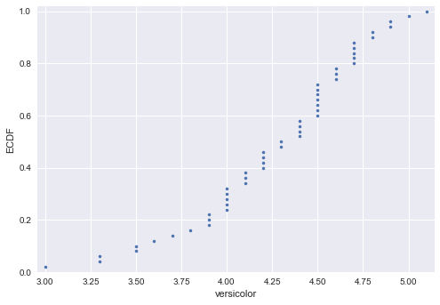

Comparison of ECDFs
ECDFs also allow you to compare two or more distributions (though plots get cluttered if you have too many). Here, you will plot ECDFs for the petal lengths of all three iris species. You already wrote a function to generate ECDFs so you can put it to good use!
To overlay all three ECDFs on the same plot, you can use plt.plot() three times, once for each ECDF. Remember to include marker='.' and linestyle='none' as arguments inside plt.plot().
- Compute ECDFs for each of the three species using your ecdf() function. The variables setosa_petal_length, versicolor_petal_length, and virginica_petal_length are all in your namespace. Unpack the ECDFs into x_set, y_set, x_vers, y_vers and x_virg, y_virg, respectively.
- Plot all three ECDFs on the same plot as dots. To do this, you will need three plt.plot() commands. Assign the result of each to _.
- Specify 2% margins.
- A legend and axis labels have been added for you, so hit 'Submit Answer' to see all the ECDFs!
setosa_petal_length = [ 1.4, 1.4, 1.3, 1.5, 1.4, 1.7, 1.4, 1.5, 1.4, 1.5, 1.5,
1.6, 1.4, 1.1, 1.2, 1.5, 1.3, 1.4, 1.7, 1.5, 1.7, 1.5,
1. , 1.7, 1.9, 1.6, 1.6, 1.5, 1.4, 1.6, 1.6, 1.5, 1.5,
1.4, 1.5, 1.2, 1.3, 1.5, 1.3, 1.5, 1.3, 1.3, 1.3, 1.6,
1.9, 1.4, 1.6, 1.4, 1.5, 1.4]

virginica_petal_length = [ 6. , 5.1, 5.9, 5.6, 5.8, 6.6, 4.5, 6.3, 5.8, 6.1, 5.1,
5.3, 5.5, 5. , 5.1, 5.3, 5.5, 6.7, 6.9, 5. , 5.7, 4.9,
6.7, 4.9, 5.7, 6. , 4.8, 4.9, 5.6, 5.8, 6.1, 6.4, 5.6,
5.1, 5.6, 6.1, 5.6, 5.5, 4.8, 5.4, 5.6, 5.1, 5.1, 5.9,
5.7, 5.2, 5. , 5.2, 5.4, 5.1]
# Compute ECDFs
x_set, y_set = ecdf(setosa_petal_length)
x_virg, y_virg = ecdf(virginica_petal_length)
x_vers, y_vers = ecdf(versicolor_petal_length)

# Plot all ECDFs on the same plot
_ = plt.plot(x_set, y_set, marker='.', linestyle='none')
_ = plt.plot(x_vers, y_vers, marker='.', linestyle='none')
_ = plt.plot(x_virg, y_virg, marker='.', linestyle='none')

# Make nice margins
plt.margins(0.02)

# Annotate the plot
_ = plt.legend(('setosa', 'versicolor', 'virginica'), loc='lower right')
_ = plt.xlabel('petal length (cm)')
_ = plt.ylabel('ECDF')

# Display the plot
plt.show()
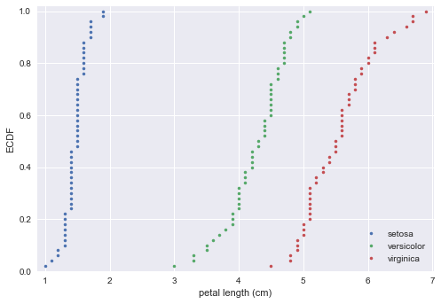
The ECDFs expose clear differences among the species. Setosa is much shorter, also with less absolute variability in petal length than versicolor and virginica.

Introduction to summary statistics : The sample mean and median

Means and medians
Which one of the following statements is true about means and medians?
- An outlier can significantly affect the value of both the mean and the median
- An outlier can significantly affect the value of the mean, but not the median
- Means and medians are in general both robust to single outliers.
- The mean and median are equal if there is an odd number of data points.
ANSWER: An outlier can significantly affect the value of the mean, but not the median

Computing means
The mean of all measurements gives an indication of the typical magnitude of a measurement. It is computed using np.mean()
- Compute the mean petal length of Iris versicolor from Anderson's classic data set. The variable versicolor_petal_length is provided in your namespace. Assign the mean to mean_length_vers.
# Compute the mean: mean_length_vers
mean_length_vers = np.mean(versicolor_petal_length)
# Print the result with some nice formatting
print('I. versicolor:', mean_length_vers, 'cm')
I. versicolor: 4.26 cm

Percentils, outliers, and box plots
Median is the special name for the 50th percentile.
In[1]: np.percentile(df_swing['dem_share'], [25,50,75])
Out[1]: array([37.3025, 43.185, 49.925])

Box plot
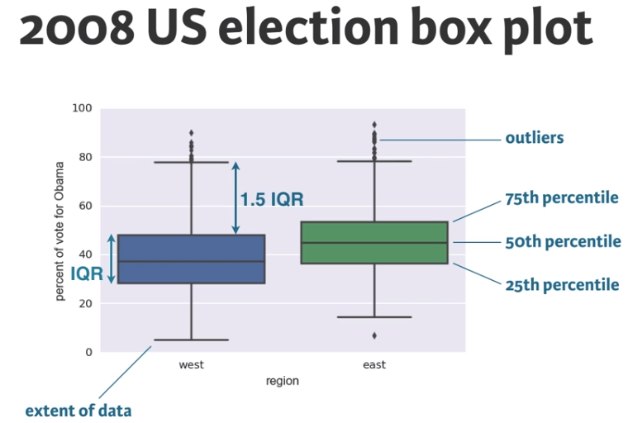
import matplotlib.pyplot as plt
import seaborn as sns
_ = sns.boxplot(x='east_west', y='dem_share', data=df_all_states)
_ = plt.xlabel('region')
_ = plt.ylabel('percent of vote for Obama')
plt.show()

Computing percentiles
In this exercise, you will compute the percentiles of petal length of Iris versicolor.
- Create percentiles, a NumPy array of percentiles you want to compute. These are the 2.5th, 25th, 50th, 75th, and 97.5th. You can do so by creating a list containing these ints/floats and convert the list to a NumPy array using np.array(). For example, np.array([30, 50]) would create an array consisting of the 30th and 50th percentiles.
- Use np.percentile() to compute the percentiles of the petal lengths from the Iris versicolor samples. The variable versicolor_petal_length is in your namespace.
# Specify array of percentiles: percentiles
percentiles = np.array([2.5,25,50,75,97.5])

# Compute percentiles: ptiles_vers
ptiles_vers = np.percentile(versicolor_petal_length, percentiles)

# Print the result
print(ptiles_vers)
[ 3.3 4. 4.35 4.6 4.9775]

Comparing percentils to ECDF
To see how the percentiles relate to the ECDF, you will plot the percentiles of Iris versicolor petal lengths you calculated in the last exercise on the ECDF plot you generated in chapter 1. The percentile variables from the previous exercise are available in the workspace as ptiles_vers and percentiles.
Note that to ensure the Y-axis of the ECDF plot remains between 0 and 1, you will need to rescale the percentiles array accordingly - in this case, dividing it by 100.
- Plot the percentiles as red diamonds on the ECDF. Pass the x and y co-ordinates - ptiles_vers and percentiles/100 - as positional arguments and specify the marker='D', color='red' and linestyle='none' keyword arguments. The argument for the y-axis - percentiles/100 has been specified for you.
# Plot the ECDF
_ = plt.plot(x_vers, y_vers, '.')
plt.margins(0.02)
_ = plt.xlabel('petal length (cm)')
_ = plt.ylabel('ECDF')

# Overlay percentiles as red diamonds.
_ = plt.plot(ptiles_vers, percentiles/100, marker='D', color='red', linestyle='none')

# Show the plot
plt.show()
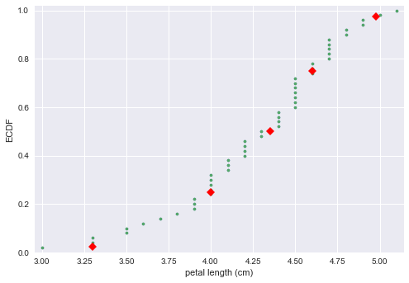

Box-and-whisker-plot
Making a box plot for the petal lengths is unnecessary because the iris data set is not too large and the bee swarm plot works fine. However, it is always good to get some practice. Make a box plot of the iris petal lengths. You have a pandas DataFrame, df, which contains the petal length data, in your namespace. Inspect the data frame df in the IPython shell using df.head() to make sure you know what the pertinent columns are.
For your reference, the code used to produce the box plot in the video is provided below:
_ = sns.boxplot(x='east_west', y='dem_share', data=df_all_states)
_ = plt.xlabel('region')
_ = plt.ylabel('percent of vote for Obama')
In the IPython Shell, you can use sns.boxplot? or help(sns.boxplot) for more details on how to make box plots using seaborn.
- The set-up is exactly the same as for the bee swarm plot; you just call sns.boxplot() with the same keyword arguments as you would sns.swarmplot(). The x-axis is 'species' and y-axis is 'petal length (cm)'.
# Create box plot with Seaborn's default settings
_ = sns.boxplot(x='species', y='petal length (cm)', data=df)

# Label the axes
_ = plt.xlabel('species')
_ = plt.ylabel('petal length (cm)')

# Show the plot
plt.show()
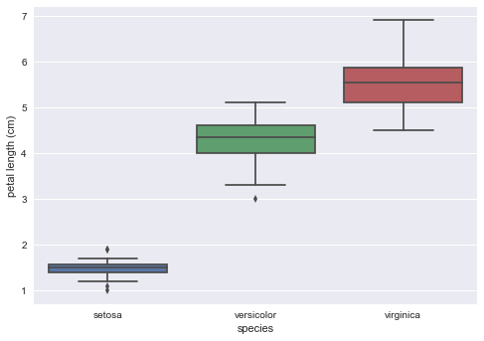

Variance and Standard deviation

Variance
- The mean squared distance of the data from their mean
- Informaly, a measure of the spread of data
np.var(dem_share_FL)

Standard deviation
np.std(dem_share_FL)
np.sqrt(np.var(dem_share_FL))

Computing the variance
It is important to have some understanding of what commonly-used functions are doing under the hood. Though you may already know how to compute variances, this is a beginner course that does not assume so. In this exercise, we will explicitly compute the variance of the petal length of Iris veriscolor using the equations discussed in the videos. We will then use np.var() to compute it.
- Create an array called differences that is the difference between the petal lengths (versicolor_petal_length) and the mean petal length. The variable versicolor_petal_length is already in your namespace as a NumPy array so you can take advantage of NumPy's vectorized operations.
- Square each element in this array. For example, x**2 squares each element in the array x. Store the result as diff_sq.
- Compute the mean of the elements in diff_sq using np.mean(). Store the result as variance_explicit.
- Compute the variance of versicolor_petal_length using np.var(). Store the result as variance_np.
- Print both variance_explicit and variance_np in one print call to make sure they are consistent.
# Array of differences to mean: differences
differences = versicolor_petal_length - np.mean(versicolor_petal_length)

# Square the differences: diff_sq
diff_sq = differences**2

# Compute the mean square difference: variance_explicit
variance_explicit = np.mean(diff_sq)

# Compute the variance using NumPy: variance_np
variance_np = np.var(versicolor_petal_length)

# Print the results
print(variance_explicit, variance_np)
0.2164 0.2164

The standard deviation and the variance
As mentioned in the video, the standard deviation is the square root of the variance. You will see this for yourself by computing the standard deviation using np.std() and comparing it to what you get by computing the variance with np.var() and then computing the square root.
- Compute the variance of the data in the versicolor_petal_length array using np.var()
- Print the square root of this value.
- Compute the standard deviation of the data in the versicolor_petal_length array using np.std() and print the result.
# Compute the variance: variance
variance = np.var(versicolor_petal_length)

# Print the square root of the variance
print(np.sqrt(variance))

# Print the standard deviation
print(np.std(versicolor_petal_length))
0.465188133985
0.465188133985

Covariance and Pearson correlation coefficient
We have more data than just the vote share for Obama. We also know the total number of votes for each county. Let's look at how these two quantities vary together. we start by looking at scatter plot of county data for the three swing states. Plotting the percent vote for Obama vs the total number of votes for each county. Immediately from the scatter plot we see that the tweleve most populus counties all voted for Obama and most of the counties with small population voted for McCain. 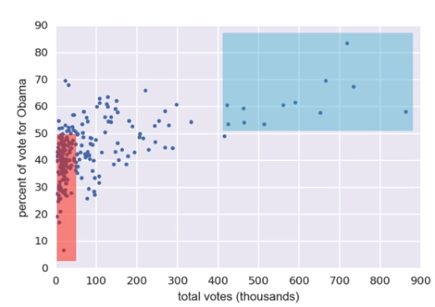

Generating a scatter plot
_ = plt.plot(total_votes/1000, dem_share, marker='.', linestyle='none')
_ = plt.xlabel('total votes (thousands)')
_ = plt.ylabel('percent of vote for Obama')

Calculation of the Covariance
We would like to have a summary statistics to go along with the information that we gleened from scatter plot. we want a number that summarizes how Obama's vote share varies with the total vote count.
One such statistics is covariance.
- A measure of how two quantities vary together.
Let's anotate the scatter plot with the means of the two quanitites we are interested in.
Look at the data point (Lucas county, Ohio) 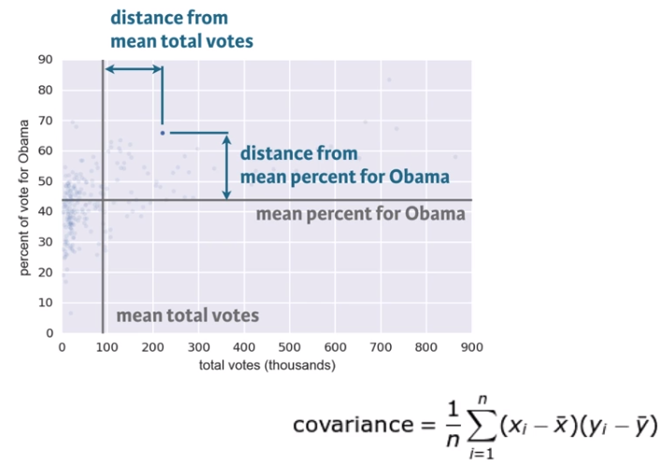 covariance is the mean of product of these differences.
If x and y both tend to be above or both below their respective means together as they are in this data set then the covariance is positive. This means they are positivily correlated. When x is high so is y. when county is more populous there is more vote for Obama.
Conversly, when x is high and y is low, the covariance is negative and data are negatively correlated.
We can compute with built in numpy function. However, if you want to have generally applicable measure how two variable depend on each other, we want to be dimensionless that not to have any units so we can divide the covariance by the standard deviation of x and y variables.
$$Rho = Pearson correlation = covariance / (std of x) (std of y)

Comparison of the variability and the data due to co-dependence (covariance) to the variability inherents in each variable independently (standard deviation).
= variability due to codependence / independent variability

conveniently is dimesionless ranges from -1 to 1 (postive correlation). value of zero means there is no correlaion. 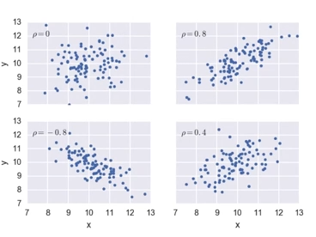

Scatter plots
When you made bee swarm plots, box plots, and ECDF plots in previous exercises, you compared the petal lengths of different species of iris. But what if you want to compare two properties of a single species? This is exactly what we will do in this exercise. We will make a scatter plot of the petal length and width measurements of Anderson's Iris versicolor flowers. If the flower scales (that is, it preserves its proportion as it grows), we would expect the length and width to be correlated.
For your reference, the code used to produce the scatter plot in the video is provided below:
_ = plt.plot(total_votes/1000, dem_share, marker='.', linestyle='none')
_ = plt.xlabel('total votes (thousands)')
_ = plt.ylabel('percent of vote for Obama')
- Use plt.plot() with the appropriate keyword arguments to make a scatter plot of versicolor petal length (x-axis) versus petal width (y-axis). The variables versicolor_petal_length and versicolor_petal_width are already in your namespace. Do not forget to use the marker='.' and linestyle='none' keyword arguments.
- Specify 2% margins so no data are cut off.
- Label the axes and Display the plot.
versicolor_petal_width = [ 1.4, 1.5, 1.5, 1.3, 1.5, 1.3, 1.6, 1. , 1.3, 1.4, 1. ,
1.5, 1. , 1.4, 1.3, 1.4, 1.5, 1. , 1.5, 1.1, 1.8, 1.3,
1.5, 1.2, 1.3, 1.4, 1.4, 1.7, 1.5, 1. , 1.1, 1. , 1.2,
1.6, 1.5, 1.6, 1.5, 1.3, 1.3, 1.3, 1.2, 1.4, 1.2, 1. ,
1.3, 1.2, 1.3, 1.3, 1.1, 1.3]
# Make a scatter plot
_ = plt.plot(versicolor_petal_length, versicolor_petal_width, marker='.', linestyle='none')

# Set margins
plt.margins(0.02)

# Label the axes
_ = plt.xlabel('versicolor_petal_length')
_ = plt.ylabel('versicolor_petal_width')

# Show the result
plt.show()
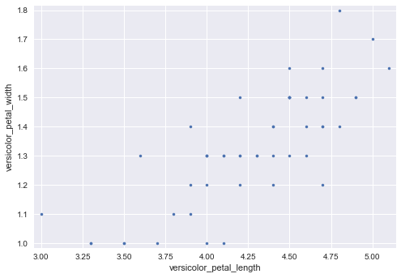

Variance and covariance by looking
Consider four scatter plots of xx-yy data, appearing to the right. Which has, respectively,
- the highest variance in the variable x,
- the highest covariance,
- negative covariance?
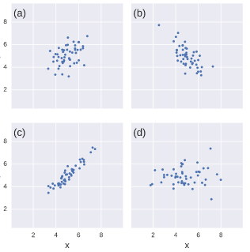 Possible Answers:
- a,c,b
- d,c,a
- d,c,b
- d,d,b
ANSWER: d,c,b

Computing the covariance
The covariance may be computed using the Numpy function np.cov(). For example, we have two sets of data x and y, np.cov(x, y) returns a 2D array where entries [0,1] and [1,0] are the covariances. Entry [0,0] is the variance of the data in x, and entry [1,1] is the variance of the data in y. This 2D output array is called the covariance matrix, since it organizes the self- and covariance.
To remind you how the I. versicolor petal length and width are related, we include the scatter plot you generated in a previous exercise.
- Use np.cov() to compute the covariance matrix for the petal length (versicolor_petal_length) and width (versicolor_petal_width) of I. versicolor.
- Print the covariance matrix.
- Extract the covariance from entry [0,1] of the covariance matrix. Note that by symmetry, entry [1,0] is the same as entry [0,1].
- Print the covariance.
# Compute the covariance matrix: covariance_matrix
covariance_matrix = np.cov(versicolor_petal_length, versicolor_petal_width)

# Print covariance matrix
print(covariance_matrix)

# Extract covariance of length and width of petals: petal_cov
petal_cov = covariance_matrix[0,1]

# Print the length/width covariance
print(petal_cov)
[[ 0.22081633 0.07310204]
[ 0.07310204 0.03910612]]
0.0731020408163

Computing the Pearson correlation coefficient
As mentioned in the video, the Pearson correlation coefficient, also called the Pearson r, is often easier to interpret than the covariance. It is computed using the np.corrcoef() function. Like np.cov(), it takes two arrays as arguments and returns a 2D array. Entries [0,0] and [1,1] are necessarily equal to 1 (can you think about why?), and the value we are after is entry [0,1].
In this exercise, you will write a function, pearson_r(x, y) that takes in two arrays and returns the Pearson correlation coefficient. You will then use this function to compute it for the petal lengths and widths of I. versicolor.
Again, we include the scatter plot you generated in a previous exercise to remind you how the petal width and length are related
- Define a function with signature pearson_r(x, y).
- Use np.corrcoef() to compute the correlation matrix of x and y (pass them to np.corrcoef() in that order).
- The function returns entry [0,1] of the correlation matrix.
- Compute the Pearson correlation between the data in the arrays versicolor_petal_length and versicolor_petal_width. Assign the result to r.
def pearson_r(x, y):
"""Compute Pearson correlation coefficient between two arrays."""
# Compute correlation matrix: corr_mat
corr_mat = np.corrcoef(x,y)

# Return entry [0,1]
return corr_mat[0,1]

# Compute Pearson correlation coefficient for I. versicolor: r
r = pearson_r(versicolor_petal_length, versicolor_petal_width)

# Print the result
print(r)
0.786668088523

Probabilistic logic and statistical inference

Thinking probabilistically - Discrete variables
Statistical inference rests upon probability. Because we can very rarely say anything meaningful with absolute certainty from data, we use probabilistic language to make quantitative statements about data. In this chapter, you will learn how to think probabilistically about discrete quantities, those that can only take certain values, like integers. It is an important first step in building the probabilistic language necessary to think statistically.
Imagine you measured the petal length of 50 spicies and calulated the mean. then repeat it again and take the mean. both mean may not be same but will be close to each other. if you continue this experiment for a very long time you will get a range of number.

What is the goal of statistical inference?
Why do we do statistical inference?
- To draw probabilistic conclusions about what we might expect if we collected the same data again.
- To draw actionable conclusions from data.
- To draw more general conclusions from relatively few data or observations.
- All of these.
ANSWER: All of these
Correct! Statistical inference involves taking your data to probabilistic conclusions about what you would expect if you took even more data, and you can make decisions based on these conclusions.

Why do we use the language of probability?
Which of the following is not a reason why we use probabilistic language in statistical inference?
- Probability provides a measure of uncertainty.
- Probabilistic language is not very precise.
- Data are almost never exactly the same when acquired again, and probability allows us to say how much we expect them to vary.
ANSWER: Probabilistic language is not very precise.
Correct. Probabilistic language is in fact very precise. It precisely describes uncertainty.

Random number generators and hacker statistics

Hacker statistics
- Uses simulated repeated measurement to compute probabilities
Coin flips, 4 heads out of 4 flips
np.random.random() will a draw a number between 0 and 1 (0 tails, 1 head)

Bernoulli trial
This is called bernouli trial
- An experiment that has two options "Success" (True) and "Failure" (False)

Random number seed
- Integer fed into random number generating algorithm
- Manually seed random number generator if you need reproducibility
- Specified using np.random.seed()
import numpy as np

np.random.seed(42)
random_numbers = np.random.random(size=4)
print(random_numbers)

heads = random_numbers < 0.5
print(heads)

np.sum(heads)
[ 0.37454012 0.95071431 0.73199394 0.59865848]
[ True False False False]
1
n_all_heads = 0

for _ in range(10000):
heads = np.random.random(size=4) < 0.5
n_heads = np.sum(heads)
if n_heads == 4:
n_all_heads += 1

n_all_heads/10000
0.0619

Hacker stats probabilities
- Determine how to simulate data
- Simulate many many times
- Probability is approximately fraction of trials with the outcome of interest

Generating random numbers using the np.random module
We will be hammering the np.random module for the rest of this course and its sequel. Actually, you will probably call functions from this module more than any other while wearing your hacker statistician hat. Let's start by taking its simplest function, np.random.random() for a test spin. The function returns a random number between zero and one. Call np.random.random() a few times in the IPython shell. You should see numbers jumping around between zero and one.
In this exercise, we'll generate lots of random numbers between zero and one, and then plot a histogram of the results. If the numbers are truly random, all bars in the histogram should be of (close to) equal height.
You may have noticed that, in the video, Justin generated 4 random numbers by passing the keyword argument size=4 to np.random.random(). Such an approach is more efficient than a for loop: in this exercise, however, you will write a for loop to experience hacker statistics as the practice of repeating an experiment over and over again.
- Seed the random number generator using the seed 42.
- Initialize an empty array, random_numbers, of 100,000 entries to store the random numbers. Make sure you use np.empty(100000) to do this.
- Write a for loop to draw 100,000 random numbers using np.random.random(), storing them in the random_numbers array. To do so, loop over range(100000).
- Plot a histogram of random_numbers. It is not necessary to label the axes in this case because we are just checking the random number generator. Hit 'Submit Answer' to show your plot.
# Seed the random number generator
np.random.seed(42)

# Initialize random numbers: random_numbers
random_numbers = np.empty(100000)

# Generate random numbers by looping over range(100000)
for i in range(100000):
random_numbers[i] = np.random.random()

# Plot a histogram
_ = plt.hist(random_numbers)

# Show the plot
plt.show()
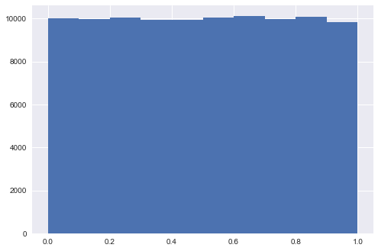
Good work! The histogram is almost exactly flat across the top, indicating that there is equal chance that a randomly-generated number is in any of the bins of the histogram.

The np.random module and Bernoulli trials
You can think of a Bernoulli trial as a flip of a possibly biased coin. Specifically, each coin flip has a probability p of landing heads (success) and probability 1−p of landing tails (failure). In this exercise, you will write a function to perform n Bernoulli trials, perform_bernoulli_trials(n, p), which returns the number of successes out of n Bernoulli trials, each of which has probability p of success. To perform each Bernoulli trial, use the np.random.random() function, which returns a random number between zero and one.
- Define a function with signature perform_bernoulli_trials(n, p).
- Initialize to zero a variable n_success the counter of Trues, which are Bernoulli trial successes.
- Write a for loop where you perform a Bernoulli trial in each iteration and increment the number of success if the result is True. Perform n iterations by looping over range(n).
- To perform a Bernoulli trial, choose a random number between zero and one using np.random.random(). If the number you chose is less than p, increment n_success (use the += 1 operator to achieve this).
- The function returns the number of successes n_success
def perform_bernoulli_trials(n, p):
"""Perform n Bernoulli trials with success probability p
and return number of successes."""
# Initialize number of successes: n_success
n_success = 0

# Perform trials
for i in range(n):
# Choose random number between zero and one: random_number
random_number = np.random.random()

# If less than p, it's a success so add one to n_success
if random_number < p:
n_success += 1

return n_success

How many defaults might we expect?
Let's say a bank made 100 mortgage loans. It is possible that anywhere between 0 and 100 of the loans will be defaulted upon. You would like to know the probability of getting a given number of defaults, given that the probability of a default is p = 0.05. To investigate this, you will do a simulation. You will perform 100 Bernoulli trials using the perform_bernoulli_trials() function you wrote in the previous exercise and record how many defaults we get. Here, a success is a default. (Remember that the word "success" just means that the Bernoulli trial evaluates to True, i.e., did the loan recipient default?) You will do this for another 100 Bernoulli trials. And again and again until we have tried it 1000 times. Then, you will plot a histogram describing the probability of the number of defaults.
- Seed the random number generator to 42.
- Initialize n_defaults, an empty array, using np.empty(). It should contain 1000 entries, since we are doing 1000 simulations.
- Write a for loop with 1000 iterations to compute the number of defaults per 100 loans using the perform_bernoulli_trials() function. It accepts two arguments: the number of trials n - in this case 100 - and the probability of success p - in this case the probability of a default, which is 0.05. On each iteration of the loop store the result in an entry of n_defaults.
- Plot a histogram of n_defaults. Include the normed=True keyword argument so that the height of the bars of the histogram indicate the probability.
# Seed random number generator
np.random.seed(42)

# Initialize the number of defaults: n_defaults
n_defaults = np.empty(1000)

# Compute the number of defaults
for i in range(1000):
n_defaults[i] = perform_bernoulli_trials(100, 0.05)

# Plot the histogram with default number of bins; label your axes
_ = plt.hist(n_defaults, normed=True)
_ = plt.xlabel('number of defaults out of 100 loans')
_ = plt.ylabel('probability')

# Show the plot
plt.show()
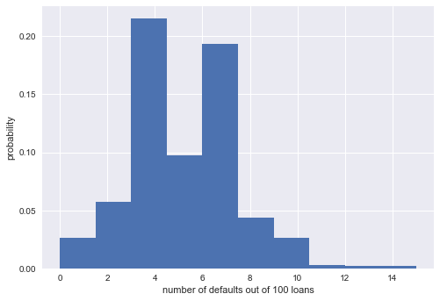
Nice work! This is actually not an optimal way to plot a histogram when the results are known to be integers. We will revisit this in forthcoming exercises.

Will the bank fail?
Plot the number of defaults you got from the previous exercise, in your namespace as n_defaults, as a CDF. The ecdf() function you wrote in the first chapter is available.
If interest rates are such that the bank will lose money if 10 or more of its loans are defaulted upon, what is the probability that the bank will lose money?
- Compute the x and y values for the ECDF of n_defaults
- Plot the ECDF, making sure to label the axes. Remember to include marker = '.' and linestyle = 'none' in addition to x and y in your call plt.plot().
- Show the plot.
- Compute the total number of entries in your n_defaults array that were greater than or equal to 10. To do so, compute a boolean array that tells you whether a given entry of n_defaults is >= 10. Then sum all the entries in this array using np.sum(). For example, np.sum(n_defaults <= 5) would compute the number of defaults with 5 or fewer defaults.
- The probability that the bank loses money is the fraction of n_defaults that are greater than or equal to 10. Print this result by hitting 'Submit Answer'!
# Compute ECDF: x, y (This function already defined above)
x, y = ecdf(n_defaults)

# Plot the ECDF with labeled axes
_ = plt.plot(x, y, marker='.', linestyle='none')
plt.xlabel('default')
plt.ylabel('ECDF')

# Show the plot
plt.show()

# Compute the number of 100-loan simulations with 10 or more defaults: n_lose_money
n_lose_money = np.sum(n_defaults >= 10)

# Compute and print probability of losing money
print('Probability of losing money =', n_lose_money / len(n_defaults))
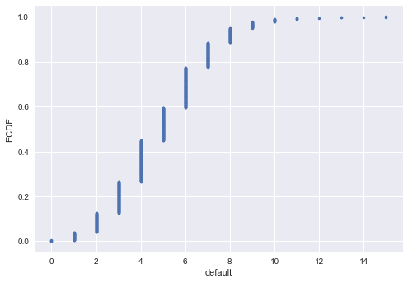
Probability of losing money = 0.022
As we might expect, we most likely get 5/100 defaults. But we still have about a 2% chance of getting 10 or more defaults out of 100 loans.

Probability distributions and stories : The Binomial distribution

Probability Mass Function (PMF)
- The set of probabilities of discrete outcomes #### Discrete Uniform PMF #### Probability Distribution
- A mathematical description of outcomes
The outcome of rolling a single fair die is Discrete Uniformly distributed

Binomial distribution
- The number r of successes in n Bernoulli trials with probability p of success, is Binomially distributed
- The number r of heads in 4 coin flips with probability 0.5 of heads, is Binomially distributed
np.random.binomial(4,0.5)
two arguments, number of bernoulli trials (coin flips-4) and the probability of success (p-0.5) We want to repeat this over and over again,
np.random.binomial(4,0.5,size=10)

samples = np.random.binomial(60,0.1,size=10000)

The likely number of success is 6 out of 60 (p-0.1) but we may expected to get as much as 11 or few as 1
Unfortunatley this is the proper way of displaying a PMF but difficult implement on matplotlib.
You will display it as histogram

The Binomial CDF
The CDF is informative as PMF but it is easier to implement
import matplotlib.pyplot as plt
import seaborn as sns
sns.set()
x,y = ecdf(samples)
_ = plt.plot(x,y, marker='.', linestyle='none')
plt.margins(0.02)
_ = plt.xlabel('number of successes')
_ = plt.ylabel('CDF')
plt.show()

Sampling out of the Binomial distribution
Compute the probability mass function for the number of defaults we would expect for 100 loans as in the last section, but instead of simulating all of the Bernoulli trials, perform the sampling using np.random.binomial(). This is identical to the calculation you did in the last set of exercises using your custom-written perform_bernoulli_trials() function, but far more computationally efficient. Given this extra efficiency, we will take 10,000 samples instead of 1000. After taking the samples, plot the CDF as last time. This CDF that you are plotting is that of the Binomial distribution.
Note: For this exercise and all going forward, the random number generator is pre-seeded for you (with np.random.seed(42)) to save you typing that each time.
- Draw samples out of the Binomial distribution using np.random.binomial(). You should use parameters n = 100 and p = 0.05, and set the size keyword argument to 10000.
- Compute the CDF using your previously-written ecdf() function.
- Plot the CDF with axis labels. The x-axis here is the number of defaults out of 100 loans, while the y-axis is the CDF.
# Take 10,000 samples out of the binomial distribution: n_defaults
n_defaults = np.random.binomial(100, 0.05, size=10000)

# Compute CDF: x, y
x,y = ecdf(n_defaults)

# Plot the CDF with axis labels
_ = plt.plot(x,y, marker='.', linestyle='none')
plt.xlabel('default')
plt.ylabel('cdf')

# Show the plot
plt.show()
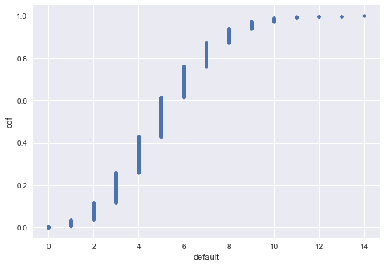
Great work! If you know the story, using built-in algorithms to directly sample out of the distribution is much faster.

Plotting the Binomial PMF
As mentioned in the video, plotting a nice looking PMF requires a bit of matplotlib trickery that we will not go into here. Instead, we will plot the PMF of the Binomial distribution as a histogram with skills you have already learned. The trick is setting up the edges of the bins to pass to plt.hist() via the bins keyword argument. We want the bins centered on the integers. So, the edges of the bins should be -0.5, 0.5, 1.5, 2.5, ... up to max(n_defaults) + 1.5. You can generate an array like this using np.arange() and then subtracting 0.5 from the array.
You have already sampled out of the Binomial distribution during your exercises on loan defaults, and the resulting samples are in the NumPy array n_defaults.
- Using np.arange(), compute the bin edges such that the bins are centered on the integers. Store the resulting array in the variable bins.
- Use plt.hist() to plot the histogram of n_defaults with the normed=True and bins=bins keyword arguments.
- Leave a 2% margin and label your axes.

Hints
- The bin edges can be computed using np.arange(), going from 0 to max(n_defaults) + 1.5. Be sure to subtract 0.5 from this array and store it in the variable bins.
- You can generate the histogram with plt.hist(), including the arguments normed=True and bins=bins alongside n_defaults.
- To specify margins, use plt.margins() with the desired margin inside the parentheses.
- Label your axes with plt.xlabel() and plt.ylabel(). Note that we are now plotting the PMF on the Y axis.
- Show your plot with plt.show().
# Compute bin edges: bins
bins = np.arange(0, max(n_defaults) + 1.5) - 0.5

# Generate histogram
_ = plt.hist(n_defaults, normed=True, bins=bins)

# Set margins
plt.margins(0.02)

# Label axes
plt.xlabel('default')
plt.ylabel('PMF')

# Show the plot
plt.show()
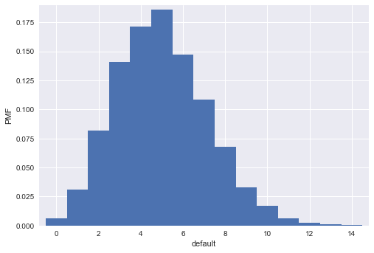

Poisson processes and the Poisson distribution
In the book of 'inofrmaiton theory and statistical inference and machine learning', Davide MacKay descirbed a town called Poissonville, where there is no bus schedule. A bus may arrive and the next bus may arrive instanly or wait for hours.

Poisson porcess
- The timing of the next event is completely independent of when the previous event happened

Examples of Poisson processes
- Natural births in a given hospital
- hit on a website during a given hour
- Meteor strikes
- Molecular collisions in a gas
- Aviation incidents
- Buses in Poissonville #### Poisson distribution
- The number r of arrivals of a Poisson process in a given time interval with average rate of λ arrivals per interval is poisson distributed
- The number r of hits on a website in one hour with an average hit rate of 6 hits per hour is Poisson distributed 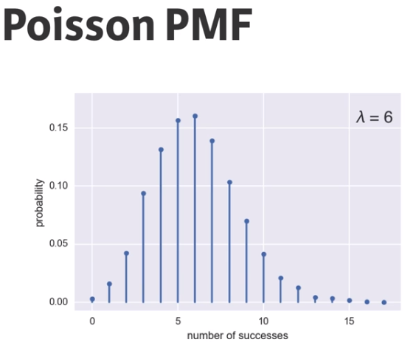 Given hour, we may get 6 hits which is the average and we may get 10 or nothing.
This looks lot like bionomial PMF, this is because Poisson distribution is the limie of Binomial distribution

Poisson Distribution
- limit of the Binomial distribution for low probability of success and large number of trials.
- That is, for rare events.

Poisson CDF
samples = np.random.poisson(6, size=10000)
x,y = ecdf(samples)
_ = plt.plot(x,y, marker='.', linestyle='none')
plt.margins(0.02)
_ = plt.xlabel('number of successes')
_ = plt.ylabel('CDF')
plt.show()

Relationship between Binomial and Poisson distributions
You just heard that the Poisson distribution is a limit of the Binomial distribution for rare events. This makes sense if you think about the stories. Say we do a Bernoulli trial every minute for an hour, each with a success probability of 0.1. We would do 60 trials, and the number of successes is Binomially distributed, and we would expect to get about 6 successes. This is just like the Poisson story we discussed in the video, where we get on average 6 hits on a website per hour. So, the Poisson distribution with arrival rate equal to np approximates a Binomial distribution for n Bernoulli trials with probability p of success (with n large and p small). Importantly, the Poisson distribution is often simpler to work with because it has only one parameter instead of two for the Binomial distribution.
Let's explore these two distributions computationally. You will compute the mean and standard deviation of samples from a Poisson distribution with an arrival rate of 10. Then, you will compute the mean and standard deviation of samples from a Binomial distribution with parameters n and p such that np=10.
- Using the np.random.poisson() function, draw 10000 samples from a Poisson distribution with a mean of 10.
- Make a list of the n and p values to consider for the Binomial distribution. Choose n = [20, 100, 1000] and p = [0.5, 0.1, 0.01] so that npnp is always 10.
- Using np.random.binomial() inside the provided for loop, draw 10000 samples from a Binomial distribution with each n, p pair and print the mean and standard deviation of the samples. There are 3 n, p pairs: 20, 0.5, 100, 0.1, and 1000, 0.01. These can be accessed inside the loop as n[i], p[i].
# Draw 10,000 samples out of Poisson distribution: samples_poisson
samples_poisson = np.random.poisson(10, size=10000)

# Print the mean and standard deviation
print('Poisson: ', np.mean(samples_poisson),
np.std(samples_poisson))

# Specify values of n and p to consider for Binomial: n, p
n = [20, 100, 1000]
p = [0.5, 0.1, 0.01]

# Draw 10,000 samples for each n,p pair: samples_binomial
for i in range(3):
samples_binomial = np.random.binomial(n[i],p[i],size=10000)

# Print results
print('n =', n[i], 'Binom:', np.mean(samples_binomial),
np.std(samples_binomial))
Poisson: 10.0086 3.18112024922
n = 20 Binom: 10.0077 2.22077479948
n = 100 Binom: 10.0199 3.00930290765
n = 1000 Binom: 10.0306 3.15113688056
The means are all about the same, which can be shown to be true by doing some pen-and-paper work. The standard deviation of the Binomial distribution gets closer and closer to that of the Poisson distribution as the probability p gets lower and lower.

How many no-hitters in a season?
In baseball, a no-hitter is a game in which a pitcher does not allow the other team to get a hit. This is a rare event, and since the beginning of the so-called modern era of baseball (starting in 1901), there have only been 251 of them through the 2015 season in over 200,000 games. The ECDF of the number of no-hitters in a season is shown to the right. Which probability distribution would be appropriate to describe the number of no-hitters we would expect in a given season?
Note: The no-hitter data set was scraped and calculated from the data sets available at retrosheet.org (license).
Possible Answers:
- Discrete Uniform
- Binomial
- Poisson
- Both Binomial and Poisson, though Poisson is easier to model and compute.
- Both Binomial and Poisson, though Binomial is easier to model and compute.
ANSWER: Both Binomial and Poisson, though Poisson is easier to model and compute.
Correct! When we have rare events (low p, high n), the Binomial distribution is Poisson. This has a single parameter, the mean number of successes per time interval, in our case the mean number of no-hitters per season.

Was 2015 anomalous?
1990 and 2015 featured the most no-hitters of any season of baseball (there were seven). Given that there are on average 251/115 no-hitters per season, what is the probability of having seven or more in a season?
- Draw 10000 samples from a Poisson distribution with a mean of 251/115 and assign to n_nohitters.
- Determine how many of your samples had a result greater than or equal to 7 and assign to n_large.
- Compute the probability, p_large, of having 7 or more no-hitters by dividing n_large by the total number of samples (10000).

Hints
- As you have done in earlier exercises, you can draw samples from a Poisson distribution using the np.random.poisson() function, passing in the mean and size as arguments.
- Recall how in an earlier exercise, you calculated the number of 100-loan simulations with 10 more defaults using np.sum(n_defaults >= 10). With a slight tweak to this code, you can calculate n_large by substituting in the appropriate number of n_nohitters that the instruction specifies.
- To compute p_large, you just have to divide n_large by the total number of samples.
# Draw 10,000 samples out of Poisson distribution: n_nohitters
n_nohitters = np.random.poisson(251/115, size=10000)

# Compute number of samples that are seven or greater: n_large
n_large = np.sum(n_nohitters >= 7)

# Compute probability of getting seven or more: p_large
p_large = n_large/10000

# Print the result
print('Probability of seven or more no-hitters:', p_large)
Probability of seven or more no-hitters: 0.0056
The result is about 0.007. This means that it is not that improbable to see a 7-or-more no-hitter season in a century. We have seen two in a century and a half, so it is not unreasonable.

Thinking probabilistically - Continuous variables
In the last chapter, you learned about probability distributions of discrete variables. Now it is time to move on to continuous variables, such as those that can take on any fractional value. Many of the principles are the same, but there are some subtleties. At the end of this last chapter of the course, you will be speaking the probabilistic language you need to launch into the inference techniques covered in the sequel to this course.

Continuous variables
- quantities that can take any value, not just discrete values

Probability density function(PDF)
- Continuous analog to the PMF
- Mathematical description of the relative likelihood of observing a value of a continuous variable

The Normal PDF
In this exercise, you will explore the Normal PDF and also learn a way to plot a PDF of a known distribution using hacker statistics. Specifically, you will plot a Normal PDF for various values of the variance.

Instructions
100xp
- Draw 100,000 samples from a Normal distribution that has a mean of 20 and a standard deviation of 1. Do the same for Normal distributions with standard deviations of 3 and 10, each still with a mean of 20. Assign the results to samples_std1, samples_std3 and samples_std10, respectively.
- Plot a histograms of each of the samples; for each, use 100 bins, also using the keyword arguments normed=True and histtype='step'. The latter keyword argument makes the plot look much like the smooth theoretical PDF. You will need to make 3 plt.hist() calls.
- Hit 'Submit Answer' to make a legend, showing which standard deviations you used, and show your plot! There is no need to label the axes because we have not defined what is being described by the Normal distribution; we are just looking at shapes of PDFs.
# Draw 100000 samples from Normal distribution with stds of interest: samples_std1, samples_std3, samples_std10
samples_std1 = np.random.normal(20, 1, size=100000)
samples_std3 = np.random.normal(20, 3, size=100000)
samples_std10 = np.random.normal(20, 10, size=100000)

# Make histograms
_ = plt.hist(samples_std1, bins=100, normed=True, histtype='step')
_ = plt.hist(samples_std3, bins=100, normed=True, histtype='step')
_ = plt.hist(samples_std10, bins=100, normed=True, histtype='step')

# Make a legend, set limits and show plot
_ = plt.legend(('std = 1', 'std = 3', 'std = 10'))
plt.ylim(-0.01, 0.42)
plt.show()

